

**700832_A20_T2 BUSINESS STRATEGY**

**ID- 201942199**

**INDIVIDUAL ASSIGNMENT PART A**

**Executive Summary-**

This is a report for Dog Pool, a dog sharing service owned and managed by Natalia Duron who has been working on it since 2015 but is now seeking for strategic advice due to the rapid growth of customers.

Strategy tools like Rich Picture, Macro economic analysis, an internal business review, PESTEL analysis, Porter’s 5 forces and competitive analysis are used to identify key issues in the current business model and recommendations are provided for the identified issues.

The key issues identified using the methodologies mentioned above were incomplete business model, lack of revenue streams, poor monetization model, dependency on IT platform and lack of marketing tools.

The recommendations provided for the key issues in a short amount of time which is known as horizon 1 were developing an app or a website to give more control to the company and eliminate dependency, creating a monetization model where customers have to pay every-time they share a dog on the app, sharing Natalia’s story on the app to attract more customers and make them connect with the cause will work as an efficient marketing tool.

In the horizon 2, A review system must be added to the app which will make dog sharing safer and customers will know if to trust the other guy or not. A customer friendly user interface should be added where customers can swipe and look at their options in their area. Messaging platform where customers can discuss their details and go through with the sharing.

In the horizon 3, organizing events for the customers with the help of sponsors to spread awareness will work great as a marketing tool. Offer loyalty schemes like regular customers who share dogs on Dog pool will get free tickets to the events for customer retention.

**Introduction-**

Dog Pool is a popular ‘Dog sharing’ service that is experiencing rapid growth. The Dog Pool service has commercialized the innovative idea of dog sharing. It allows people without dogs to enjoy some of the benefits of owning a dog and the busy owners to keep their loved dog entertained while they’re at work or out of town.

This report is made to tackle the challenges Natalia, the founder of Dog Pool is facing due to a rapid growth of the company. Natalia started this company out of her love and care for animals. Therefore, the cause of the company should be protected at any circumstances.

This report consists of the introduction, analysis of the internal and external environment, the methods used for the analysis and future recommendations for Dog Pool.

**Methodology-**

**Step 1- Situation Mapping**

At the start of this report, firstly we need to explore the situation we are in. A great way to do the situation analysis is by drawing the Rich Picture. The main objective of drawing the rich picture is to identify the key issues and work on it. Rich picture also provides the broader view of the situation.

**Step 2- Macro Environmental Analysis**

Even if the future cannot be predicted perfectly, it is clearly important to analyse the environment to anticipate and if possible take advantage of the changing environment. The objective of doing the environmental analysis is to identify the threats and opportunities which are created by the environment. The PESTEL analysis is one of the several frameworks which categorise environmental factors into key types. It highlights six environmental factors in particular, political, economic, social, technological, ecological and legal. This list tells us that environment includes both economics of market and non-market factors.

**Step 3- Internal review of the Business**

Internal review of a Business includes its business model analysis and identification of its resources and competences.

**Step 4- Competition Analysis**

Porter’s 5 forces framework helps us to analyse an industry and identify the attractiveness of it in five competitive forces, extent of rivalry between competitors, threat of new entrants, threat of substitute, power of buyers and power of suppliers.

**Step 5- Produce project outputs**

**Step 1 Situation Mapping**

**Rich Picture**

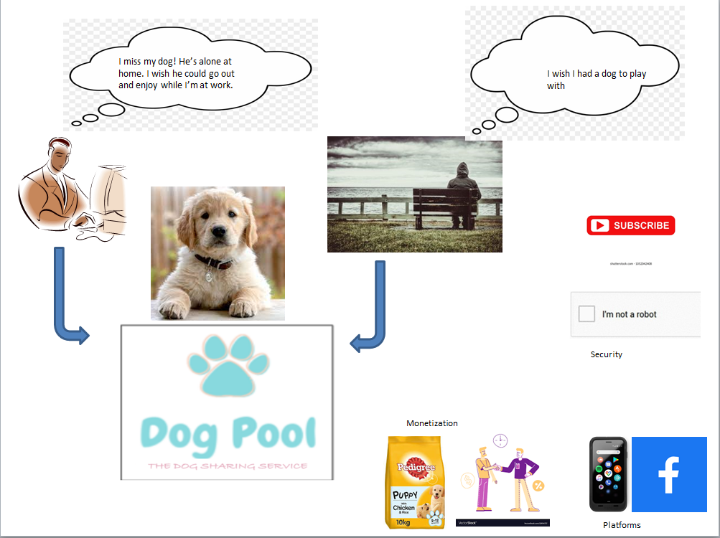

The rich picture has helped us identify certain problems. The main problems here are the monetization of the business model, dependency on the Facebook group, customer retention, development of business model and the amount of time spent on checking on the new members.

The customers or the members only pay the Facebook group joining fees when they join the group which is not efficient for the company in the long run and it also takes away the control over the later transactions or dog sharing from the group admin.

The dependency on the Facebook group makes the future of the company uncertain because they can change their policies anytime, charge a fee or delete the group.

As Natalia does not have any control over the dog sharing after the members join the group, she does not receive any commission on dog sharing and it also gives the members an opportunity to do the transactions individually after they get to know each other.

Dog pool needs to automate the process of checking on the new members as it is not efficient to dedicate most of the time to do so. The same time can be dedicated towards the development of the business model which suits Natalia’s vision of animal welfare.

After the Rich picture, the stakeholder analysis is performed to assess how the interests of the stakeholders should be addressed in the business model.

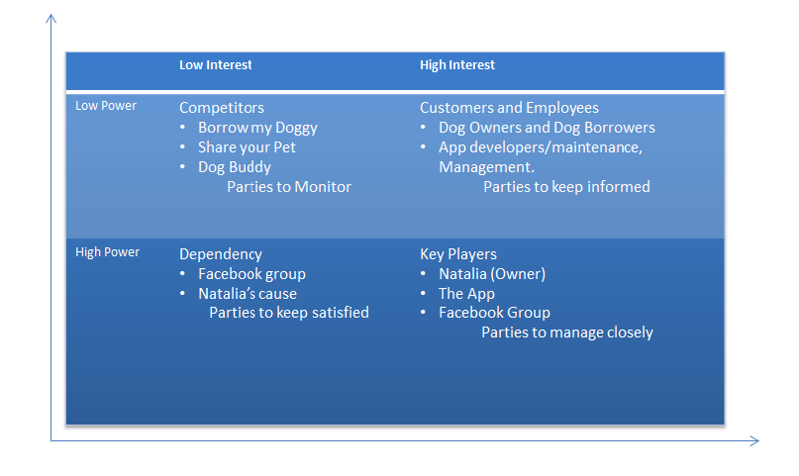

Stakeholders are those individuals or groups that depend on an organization to fulfil their own goals and on whom, in return the organization depends on. These stakeholders can be diverse, including owners, customers, suppliers, employees and local communities.

**Step 2 Macro-Environmental Analysis**

**PESTEL Analysis**

**Political**- The importance of political factors is quite low for this business as there is no transaction of a physical product.

**Economic**- As Dog Pool is a domestic business, it should not be concerned about the fluctuating currencies, economic growth rates and the economy as a whole.

**Social**- The demographics will have a major influence on the market. Example, the area where there are a lot of dog owners and dog borrowers will benefit the business the most. Culture will be a major influence on the business as well, as some people might not look at Dog Pool as a good idea.

**Technological**- Technology is the most important aspect for Dog pool as it uses an online platform. The customers for the company are directly related with how many people use the internet. The faster and accessible the internet is in the UK, it will be better for the business.

**Ecological**- There is no direct impact of Dog Pool on the environment as there is no transaction of a physical product with harmful packaging.

**Legal**- There could be legal problems if a shared dog bites the borrower and the company would have to take the responsibility for it. As online abuse is on the rise, there should be strict policies against people with ill intent.

**Step 3 Internal review of the business**

**Business Model Canvas**

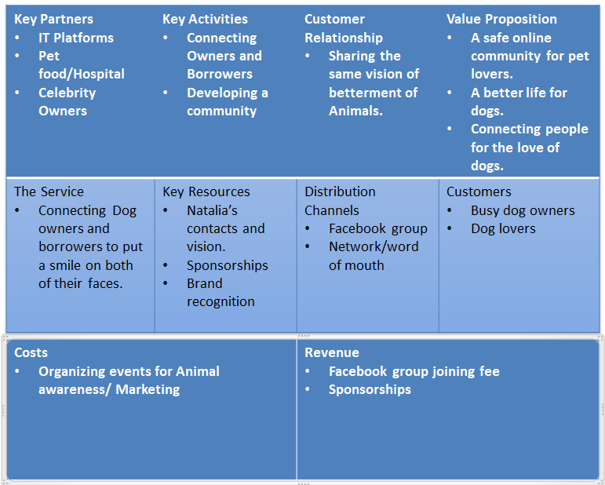

This Business model canvas concentrates on the owner’s vision to provide a better life for Dogs when their owners are not at home. This model is not sustainable and consumes more time of the owner than it should. The revenue streams are just one time Facebook group joining fees and sponsorships for events which is not enough for a legitimate business to thrive. The company also loses control once people have met each other and they can decide to go on with the transaction without giving a commission to the company which is all down to the dependency on Facebook. This model can be good for a charity but not for a competitive business.

**Step 4 Competition Analysis**

**Porter’s 5 forces**

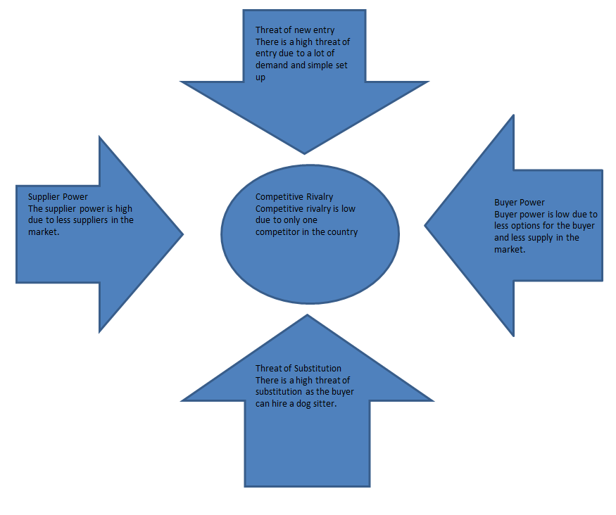

**New Entrants**- The threat of new entrants is very high due to a simple set up and a lot of demand. The concept of Dog Pool is easy to copy as well, anyone can set-up a website or an app and provide the same service Dog Pool provides.

**Threat of Substitution**- Hiring a Dog sitter is the only substitute to the service Dog Pool is providing. Dog sitters are much more expensive than Dog sharing. Therefore, it is not to be worried about. Dog sharing is also for the purpose of happiness and enjoyment of both the dog borrower and the dogs. Whereas, Dog sitters do it for the money they get out of it.

**Buyer Power**- The buyer power is low due to less-options for them to buy from and a higher demand, in the market. Therefore, the supplier has an upper hand on the pricing and quality.

**Supplier Power**- The supplier power is high due to less number of suppliers in the market and high demand. The suppliers are also not dependant on the industry they supply.

**Competitive Rivalry**- Competitive rivalry is comparatively low in this industry with borrow my doggy being the only competition. Borrow my doggy is leading the market currently because of a better IT platform and monetization model.

**Comprtitive Performance Review**

As per the information mentioned in the graph, Borrow my doggy is leading the market in service offering, profiles quality, insurance and IT platform. Dog pool has a higher pricing than Borrow my doggy but is committed more to the cause of animal welfare with a visible leader in Natalia. It has a better online and local community compared to borrow my doggy.

**Competitive SWOT Analysis**

**Weakness**

* Higher Price
* Weak IT System and Monetization model
* Weak service offering

**Strengths**

* Commitment to the cause of Animal welfare
* Strong Community
* Natalia’s story and passion

**Threats**

* Borrow my doggy
* New Entrants
* Substitutes like Dog sitters

**Opportunities**

* Organizing events like dog shows to tap into a wider market
* Monetizing the business model

**Stage 4 Recommendations**

Horizon 1

* Switch the IT system from Facebook group to an App or a website so there’s no reliability on anyone and the management will have control over the operations.
* As the control is shifted from a third party IT system to the management, a subscription model can be implemented which will allow to charge a fee for both dog owners and borrowers every-time they lend the dog. The customers will be happy to pay the amount because of the overall experience they will be getting which will include locating dog owners or borrowers in their area and completing the transaction on the same IT platform.
* Natalia’s story should be shared on the app so everyone can connect with her vision.

Horizon 2

* Add review system to the App or website which will mean both dog owners and borrowers would post reviews about their experiences with each other so the community can grow safely and the new members will have an idea about what they’re getting into.
* A customer friendly user interface like Tinder or Bumble where customers can swipe right or left to choose from the options in their area will make the app user friendly and exciting to use for the customers. Looking at options in this way will make the customers share or borrow dogs on Dog Pool itself.
* A messaging platform should be provided for the customers where they can discuss the details and contact information should not be shared which will make them stick to Dog Pool.

Horizon 3

* Organize events like dog shows with the help of sponsorships from dog food brands and pet hospitals to grow the community and also spread animal awareness which is the main objective of the company. These events will work great as a marketing tool for Dog Pool.
* Offer loyalty schemes to the regular customers like customers who regularly use dog pool for sharing dogs will get free tickets to the events. This will boost customer retention and customers will have an incentive to use dog pool their second time and not contact each other outside.

**INDIVIDUAL ASSIGNMENT- PART B**

**FACTOR- RESOURCE AND CAPABILITIES**

How do Resources and Capabilities of a company affect making of its business strategy?

This essay explains the vital importance of resources and capabilities of an organization in the process of its strategy making.

A company is affected by both its internal and external environment. Resource and Capabilities of a company are the sources available for them to succeed. Every company has different resources and capabilities. They are heterogeneous in this respect. It can be very difficult for an organization to imitate or obtain the resources and capabilities of some other organizations. Resources and capabilities are the implications of differences between organizations and can be used as competitive advantage against other organizations in the industry. Superior performance of an organization can be down to the resources available to them. These concepts are known as the resource based view of strategy which also sometimes is labelled as capabilities view. Resources and capabilities are used by managers to figure out their short term and long term goals and identify their competitive advantages compared to other organizations in the industry. Resources are the assets that organizations have or can call upon and capabilities are the ways those resources are used or deployed (Johnson, 2019). One is as important as the other as the resources available at an organization is as important as how it is used or deployed. The available resources don’t count if the managers don’t know how to use them to gain an advantage against other organizations using the resources. The efficiency and effectiveness of financial and physical resources, or the people in an organization, depend not just on the existence, but on the systems and processes by which they are managed, the relationships and cooperation between people, their adaptability, their innovative capacity, the relationships with customers and suppliers, and the experience and learning about what works well and what does not (Johnson, 2019).

There are two types of resource and capabilities, the first one is threshold resource and capabilities and the other one is distinctive resource and capabilities. Threshold resource and capabilities are those needed for an organization to meet the necessary requirements to compete in a given market and achieve parity with the competitors in the market (Johnson, 2019). Without these, organizations could not survive over time. Many new entrants in a market find it difficult to obtain the resource or capabilities needed to compete with the established competitors in a market. The threshold resource and capabilities could keep changing with time to satisfy the minimum customer requirements. For example, during lockdown in the pandemic, every restaurant had to have minimum requirements to deliver their food to the customers at home to compete with the other restaurants or to simply survive. Threshold resource and capabilities could also change due to success of other competitors or due to new entrants. As threshold resource and capabilities are those that can be imitated by other competitors, they do not create any competitive advantage for an organization. On the other hand, distinctive resource and capabilities are the ones who can create competitive advantage for an organization on its competitors. Distinctive resource and capabilities cannot be imitated by their competitors, they are like a trademark for an organization. For example, the technology used by apple in its electronic devices is their trademark and it provides them with competitive advantage over their competitors. Therefore, distinctive resource and capabilities are necessary for sustainable competitive advantage and superior economic performance (Johnson, 2019).

Distinctive resource and capabilities are further assessed into four different categories on the basis of achieving competitive advantage, which are as follows, value, rarity, inimitability and organizational support. The analysis of this distinctive resource and analysis is also called as the VRIO analysis. Valuable resource and capabilities are those which create a product or a service that is of value to the customers and enables the organization to respond to environmental opportunities and threats (Johnson, 2016). Value for customers is produced by either lowering the price of the product or increasing the attractiveness of the product. For example, IKEA has valuable resources in its cost-conscious culture and size and its interlinked capabilities that lower its cost compared to its competitors, and this addresses opportunities and customer value of low-priced designer furniture that competitors do not attend to (Johnson, 2019). If competitors in an industry have similar resource and capabilities, they can respond to their competitor’s initiative quite fast which often happens in the smartphone industry. On the other hand, rare resource and capabilities offer longer competitive advantage to an organization. For example, Coca Cola has a rare kind of recipe for their product which is a top secret that gives them a competitive advantage over their competitors in the soft drinks industry. Inimitable resource and capabilities are those which are difficult and costly for the competitors to imitate and are hard to find a substitute as well. These resource and capabilities are very rare and can include geographical location advantage, certain raw materials and brands. Competitive advantage is more likely to be determined by the capabilities as any competitor can buy marketing tools but it depends on how they use it. Compared to physical assets and patents, capabilities tend to involve more intangible imitation barriers (Johnson, 2019). It is hard for an organization to imitate resource and capabilities of its competitors because of the involvement of both internal and external inter-linkages. Internal linkages include the activities and processes inside an organization which cannot be easily imitated and external linkages are the connections of an organization or the celebrities which endorse their product. It can be very difficult to get a hold of similar connections to make a similar impact. Organizational support is probably the most important aspect to gain competitive advantage as an organization must be suitably arranged to support the resource and capabilities through its internal processes and systems. In order to take full advantage of the resource and capabilities an organization’s structure and formal and informal management control systems need to support and facilitate their exploitation (Johnson, 2019). It is hard to gain competitive advantage of the available resource and capabilities if the organization is not well organised. For example, if an organization has a product with huge demand in the market but doesn’t have a proper sales team to exploit that demand, the competitive advantage will be hard to gain over its competitors. Therefore, to achieve a competitive advantage over its competitors, an organization has to consider how and to what extent it has capabilities which are valuable, rare, inimitable, and supported by the organization (Johnson, 2019). The VRIO analysis helps us to know how and to what extent an organization has resource and capabilities that are valuable, rare, inimitable, and to what extent is supported by the organization. This analysis can be done for different functions in an organization like manufacturing, technology, marketing, sales and purchasing. Benchmarking is a tool used to compare an organization with others.

In conclusion, we can say that the analysis of resource and capabilities is very important for an organization to make its strategic plans as it can tell us if the organization can survive or obtain any competitive advantage over its competitors in its industry. Getting to know the same, the resource and capabilities available to the organization can be used more efficiently. It also helps us to know what kind of resource and capabilities do big players in the industry have and what is needed to get to that level. The analysis of resource and capabilities also tells us that the capability of deploying or using the resources is as important as the available resources.

**References-**

Johnson, G., 2019. *Exploring Strategy, Text and Cases*. 10th ed. New York: Pearson Education, Limited.